

**NAME** :  *KASHIF MAJID DAR*

**BRANCH**:  *CS B-1*

**BATCH**: *2019-23*

**PRN:**  *19070122084*

**ASSIGNMENT 2:**

1. The following empty flowchart gives the steps to be followed while seeking admission to new school. The phrases to be filled in the boxes are also given. Complete the flowchart by filling in the number of the corresponding phrase, inside each box. For example: the number corresponding to the first box in the flowchart is 7
2. Search for a school
3. Prepare for the admission test and write the test.
4. Did you pass the exam?
5. Submit necessary documents and get admission.
6. End
7. Are seats available?
8. Start

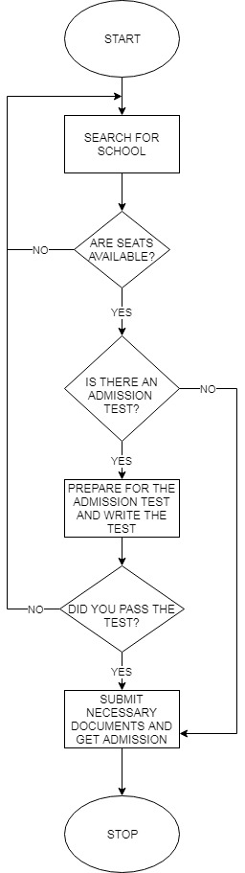

1. Design and develop a flowchart or an algorithm take three coefficients a ,b and c of a quadratic equation (ax2+bx+c=0) as input and compute all possible roots.

ALGORITHM: -

1. START

2. ENTER A, B AND C

3. ROOT1=0, ROOT2=0

4. IF A=0

5. PRINT ROOTS NOT POSSIBLE

6. GO TO 17

7. D=B2-4*A*C

8. IF D>0

9.,

10. PRINT REAL AND UNEQUAL ROOTS, ROOT1,ROOT2

11. IF D=0

12.,

13. PRINT REAL AND EQUAL ROOTS, ROOT1, ROOT2

14. IF D<0

15.,

16. PRINT IMAGINARY ROOTS, ROOT1,ROOT2

17. STOP

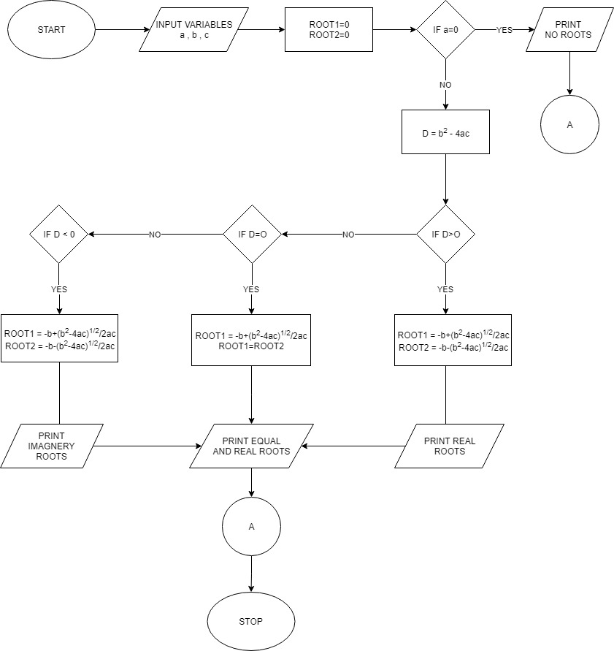

1. There are four types of fruits Apples, Oranges, Bananas and Grapes. Each student can pick up two fruits. There are some conditions which have to be used to pick up the fruits. Draw a flow chart which can take the name of first fruit as an input and print the names of second fruit or fruits that can be picked up.

|  |  |
| --- | --- |
| If you pick an apple you can pick banana. |  |
| If you pick orange you can pick grapes. |
| If you pick grapes you can pick banana. |
|  |

Hint: There will be one input box to read the first fruit, three decision boxes and four output

boxes in flow chart.

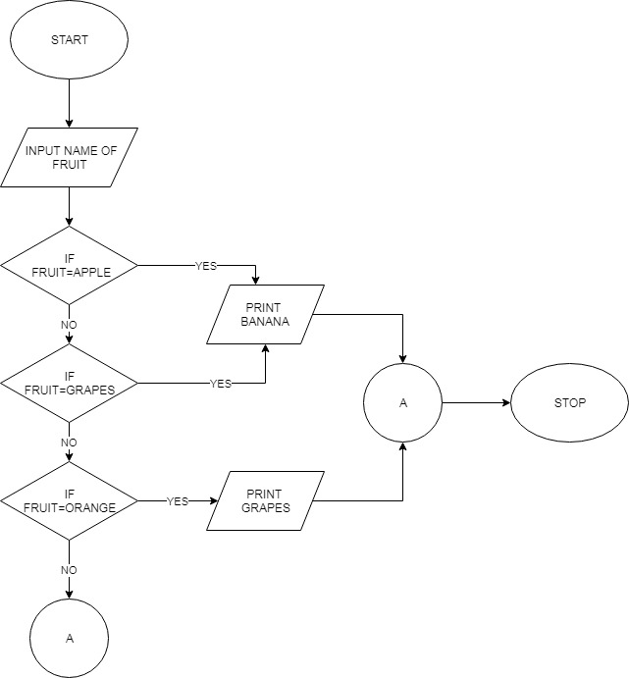

1. Lengths of three sides of a triangle a, b, c are given as input. The following flowchart finds if the triangle is isosceles, equilateral, or scalene. Some boxes in the flowchart are filled in for you, fill in the rest of the details.

Hint: In an equilateral triangle three sides are equal.

In an isosceles triangle two sides are equal.

In a scalene triangle three sides are not equal.

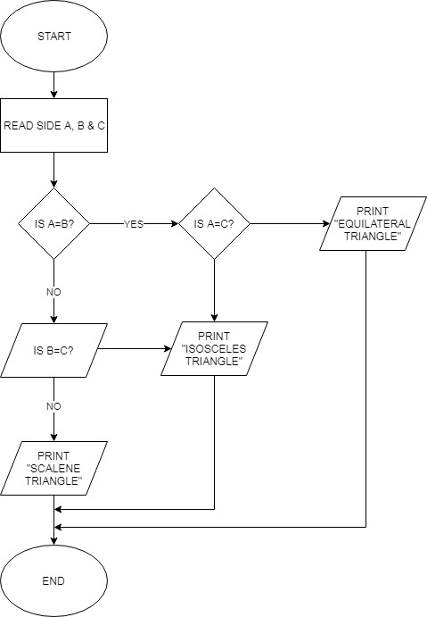

1. Draw flowchart and algorithm : Calculate the Interest of a Bank Deposit (At least for 3 banks)

ALGORITHM: -

1. START

2. ENTER THE PRINCIPLE AMOUNT (P) AND TIME PERIOD(T)

3. START A FOR LOOP WITH I AS THE VARIABLE FROM 0 TO 3

4. ENTER THE RATE (R).

5. INTEREST=0

6. INTEREST=(P*T*R)/100

7. PRINT INTEREST

8. CHECK IF I IS LESS THAN 3

9. IF YES THEN GO TO 4.

10. OR GO TO 11

11. STOP

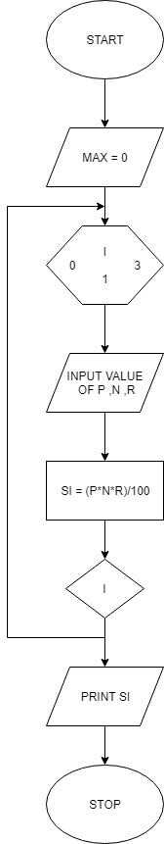

1. Draw flowchart and algorithm : Print even number between 1-100

ALGORITHM:-

1. START
2. BEGUN A FOR LOOP WITH i AS VARIABLE FROM 1 TO 100
3. IF I/2 REMINDER IS EQUAL TO 0
4. PRINT i
5. ELSE GO TO LINE 2
6. CHECK IF i IS LESS THEN 100
7. IF YES GO TO LINE 2
8. IF NOT GO TO LINE 9
9. STOP

